Warning – Buckle Up - CGEA1.3

Functional Description

The purpose of the MyKey Buckle Up Warning is to provide the MyKey Restricted User with a visual warning when any monitored seat belt is not used. The warning will also correlate the lack of seat belt usage to the muting of the radio. The radio mute information to be displayed in the Message Center is redundant to the display on the radio.

The MyKey Buckle Up Warning correlates the Current Ignition Key Device Type and the cluster BeltminderAudioMute output state to determine when to display the MyKey Beltminder message center warning.

Interfaces

Interface Context Diagram (I/O Block Diagram)

Figure 1 Warning – MyKey Buckle Up
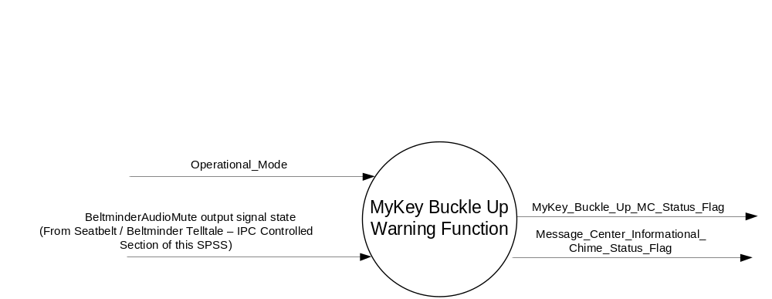

Inputs
      - INTERNAL:
    - Operational_Mode
- MUX message output current state (signal sent to multimedia to mute radio).

- BeltminderAudioMute Signal (Cluster Output*)
Signal Name | Size (bits) | Detail | Units | Res. | Offset | State Encoded | Min | Max
BeltminderAudioMute | 1 |  | SED | 1 | 0 |  | 0  (0x0) | 2  (0x2)
 |  | Invalid |  |  |  | 0x0
 |  | Off |  |  |  | 0x1
 |  | On |  |  |  | 0x2
- Note: This is a cluster output whose state is controlled as per Seatbelt /Beltminder Telltale – IPC

Controlled section of this STSS. Cluster Buckle Up message is displayed based on the state of this output.

Output
MyKey_Buckle_Up_MC_Status_Flag that is used to control the Warning displayed in the message center.
Message_Center_Informational_Chime_Status_Flag

Function/Performance

Operational Modes

Mode | Differentiating Vehicle Conditions
Sleep Mode | MyKey_Buckle_Up_MC_Status_Flag = Inactive
Limited Mode | MyKey_Buckle_Up_MC_Status_Flag = Inactive
Normal Mode | MyKey_Buckle_Up_MC_Status_Flag = Inactive/Active
Crank Mode | MyKey_Buckle_Up_MC_Status_Flag = Inactive/Active

The above table references the setting of the Warning flag as per this section. However, the actual warning display operational modes are displayed in the Message Center section of this SPSS.

Voltage Levels

Refer to the Cluster Features Table located in the Operational Modes and Voltage Range Strategies Section of this SPSS

Human-Machine Interface

Visual

1.3.3.1.1 Indicator Graphics / Display Format
Message Center Text Warning Message as defined in section 1.3.5.7 of this document.

1.3.3.1.2 Indicator Color Coordinates

Reference section COLOR & ILLUMINATION REQUIREMENTS (GRAPHICS).

Audio

The Message Center Informational Warning Chime is associated with this Warning.

Switch Control Logic

None.

System Accuracy

Within 100 msec of receiving a message that results in a change of state the cluster will update the output flag to the proper state.

Operation: Performance and Functional

Subsystem Algorithm Flowchart / State Diagram

- State Matrix for MyKey Buckle Up Warning
Operational_Mode | BeltminderAudioAudioMute  Signal Output State | MyKey_Buckle_Up_MC_Status_Flag | Active Chime_Status_Flag
Normal or Crank | On (0x2) | Active | Message_Center_Informational_  Chime_Status_Flag
All Other Cases |  | Inactive | None

Operation Description (supports algorithm flowchart /state diagram)

- When MyKey_Buckle_Up_MC_Status_Flag = ACTIVE, Warning ID W880 will be ACTIVE.
- For definition of how the Message Center arbitrates and displays Active warnings, see the Warning / Alert Display Logic Diagram, located in the Message Center – X Display with W Button Interface section of this SPSS (where X and W are appropriate values in this document).

Function Safety Classification (EMC)

Class B

Memory Storage

Parameter Name | Description | Value at  Battery Connect | Value at  Module Wake-up
MyKey_Buckle_Up_MC_Status_Flag | State Variable used by M/C Warning Arbitrator | Inactive (0x0) | Inactive (0x0)
BeltminderAudioMute | Cluster output signal used to mute radio. | As per Seatbelt /Beltminder Telltale – IPC Controlled section of this SPSS.
Operational_Mode | 4 state indicator for cluster operational mode | Limited | Limited or Normal or Crank
Message_Center_Informational_  Chime_Status_Flag | Used to control the state of the chime to the Chime Arbitrator | Inactive | Inactive

Prove Out

No.

Reconfigurable Telltale

No.

Message Center Msg

Warning Message ID W880 as defined in the Text Message List section of this SPSS.

Error Handling

Missing Message Strategy

Does not apply as BeltminderAudioMute is cluster output.

Diagnostics

Self Test

None

Engineering Test Mode

Not Applicable

Part II Performance

Supported Diagnostic Trouble Codes (DTCs)
None

Reference Specification
IS-0001 WARNINGS/INDICATORS/DISPLAYS PROVEOUT
IS-0052 OPERATING VOLTAGES - FUNCTIONAL/PERFORMANCE
IS-0069 FUNCTIONAL IMPORTANCE CLASS
IS-0324 WINDSHIELD & OTHER REFLECTIONS
IS-0327 WARNING INDICATOR EVALUATION
IS-0379 NORTH AMERICAN WARNINGS AND INDICATORS STRATEGY
IL-0017 TELLTALE AND INTERIOR ILLUMINATION – COLOR AND INTENSITY
IL-0019 GENERAL ILLUMINATION DIMMING
IL-0021 CRAFTSMANSHIP – DISPLAYS
IL-0022 GENERAL ILLUMINTATION COLOR
IL-0023 CLARITY/LEGIBILITY/READABILITY/VISUAL CONTRAST
IL -0043 OPERATIONAL ENVIRONMENT FUNCTIONALITY
IL -0045 COLOR
IL -0047 TELLTALE, INDICATOR AND DISPLAY LIGHT INTENSITY
IL -0048 ILLUMINATION ACCEPTABILITY

03-0661 PLACEMENT: CONTROL AND DISPLAY LOCATIONS
03-0662 PLACEMENT: LOGICAL GROUPING FUNCTION AND USAGE
03-0664 PLACEMENT: DOWN VISION TO COMPONENTS WITH HIGH VISUAL DEMAND
03-0665 PLACEMENT: EXPECTED LOCATIONS OF CONTROLS AND DISPLAYS VDS
03-0670 INTERIOR VISIBILITY
03-0671 INTERIOR VISIBILITY: REFLECTIONS FROM COMPONENTS & SURFACES
03-0672 INTERIOR VISIBILITY: REFLECTIONS IN DISPLAYS
03-0673 INTERIOR VISIBILITY: VISUAL OBSCURATIONS
03-0674 INTERIOR VISIBILITY: ILLUMINATION CONTROLS / DISPLAYS
03-0675 INTERIOR VISIBILITY: VEILING GLARE
03-0677 INTERIOR VISIBILITY: SUNLIGHT WASHOUT
03-0681 IDENTIFICATION: CHARACTER AND SYMBOL SIZE
03-0682 IDENTIFICATION: LEGIBILITY
03-0685 IDENTIFICATION: SYMBOLS, ABBREV FOR CONTROL

Revision History

SPSS Module Revision History

Revisio  Level | Name | Change Description | Date
1.0 | V. Patel | Updated for CGEA 1.3 based on CGEA STSS v3.0  Section 1.2.2 – Removed table referencing the HS-CAN message that contains the input signal.  Section 1.4 – Rewritten. Deleted references of specific missing message flags and timer.  Section 1.5.3 – Deleted DTC logging criteria from the table. | 4/13/2010
2.0 | JBlatchf | This change updates activation of warning message to BeltminderAudioMute cluster output state.  Updated 1.1, Figure 1, Table 1, Table 1.1 , 1.3.5.4, and 1.4.1 | 3/18/2011
2.1 | JBlatchf | This change removes Current_Ign_Key_Dev_Type as input in Figure 1. Not used in v2.0. No impact to function. | 7/11/2011
2.2 | TCwik1 | This change removes MyKey_Volume_Limit_Cfg as input in Figure 1 and from Sections 1.2.1 and 1.3.5.4. Also, removed Current_Ign_Key_Dev_Type from Section 1.2.2. These are not used in v2.0. No impact to function. | 2/18/2013
2.3 | Ilopezla | This is update adds the Chime Status Flag associated with this warning as per Global_Msg_List_ver32_Released_6_24_2015(all changes are highlighted in blue)  Section 1.2.1 Figure 1 Added Message_Center_Informational_Chime_Status_Flag  Section 1.2.3 Added Message_Center_Informational_Chime_Status_Flag  Section 1.3.3.2 Added Message_Center_Informational_Chime_Status_Flag  Table 1.1 Added Active Chime_Status_Flag column.  Section 1.3.5.4 Added Message_Center_Informational_Chime_Status_Flag to Memory Storage Table | 1/6/2016

